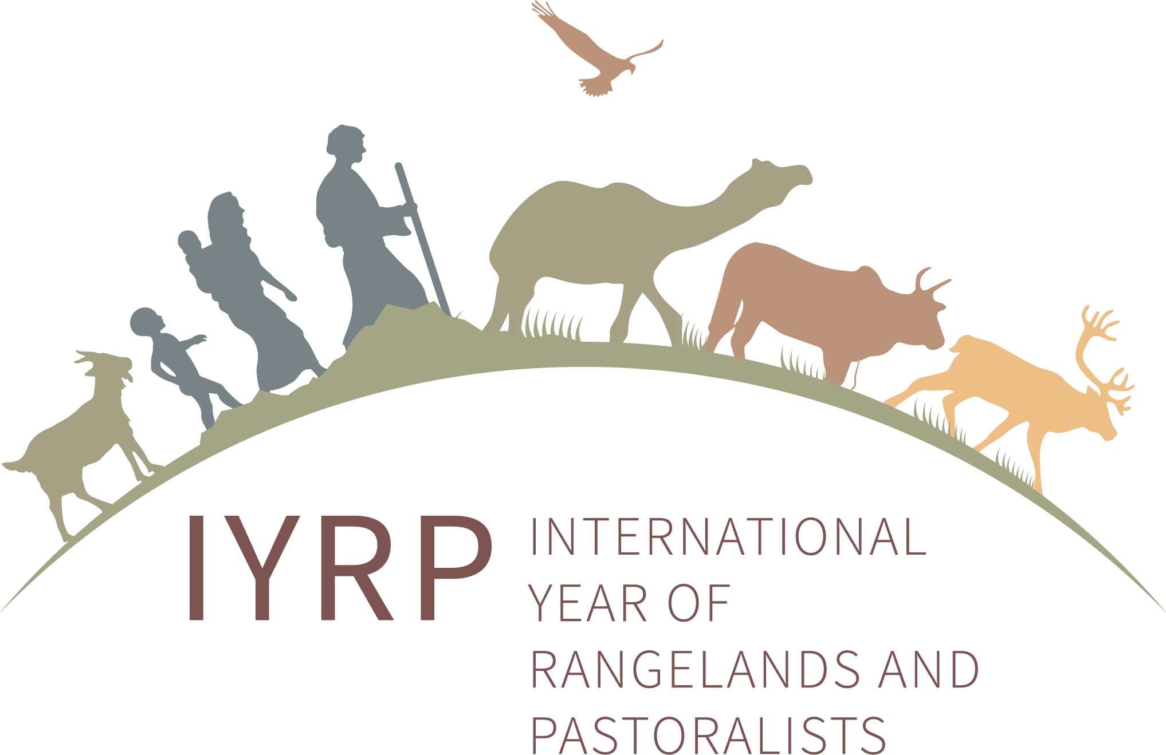
Launch of the IYRP 2026 in Northern Portugal
28 March 2023, Alvão Mountains

The association Terra Maronesa hosted the launch of the IYRP 2026 in Portugal on 28 March 2023. The event was filled with activities in the Serra do Alvão and benefited from national media coverage. Participants came from Portugal and Spain.

In the morning, they had the opportunity to witness a demonstration of flock management with Bravia goats, a local indigenous breed, and to engage in dialogue with partners about a common agenda of work towards 2026.

In the afternoon, the LIFE Maronesa project was presented with Maronesa cattle breeders, a local indigenous breed that gave the association its name, and participants discovered the House of Livestock Farming, a new interpretive centre for pastoralism.

This was the first initiative in Portugal related to the IYRP 2026, aimed at mobilising pastoralist communities and raising awareness among the wider society about the importance of pastoralism.

The event was co-organised by WWF Portugal, ANCABRA – National Association of Bravia Goat Breeders, RHE Initiative, the Union of Parishes of Pensalvos and Parada de Monteiros, the Local Community – Baldios de Cabanes, the House of Livestock Farming, BPI and La Caixa Foundation.

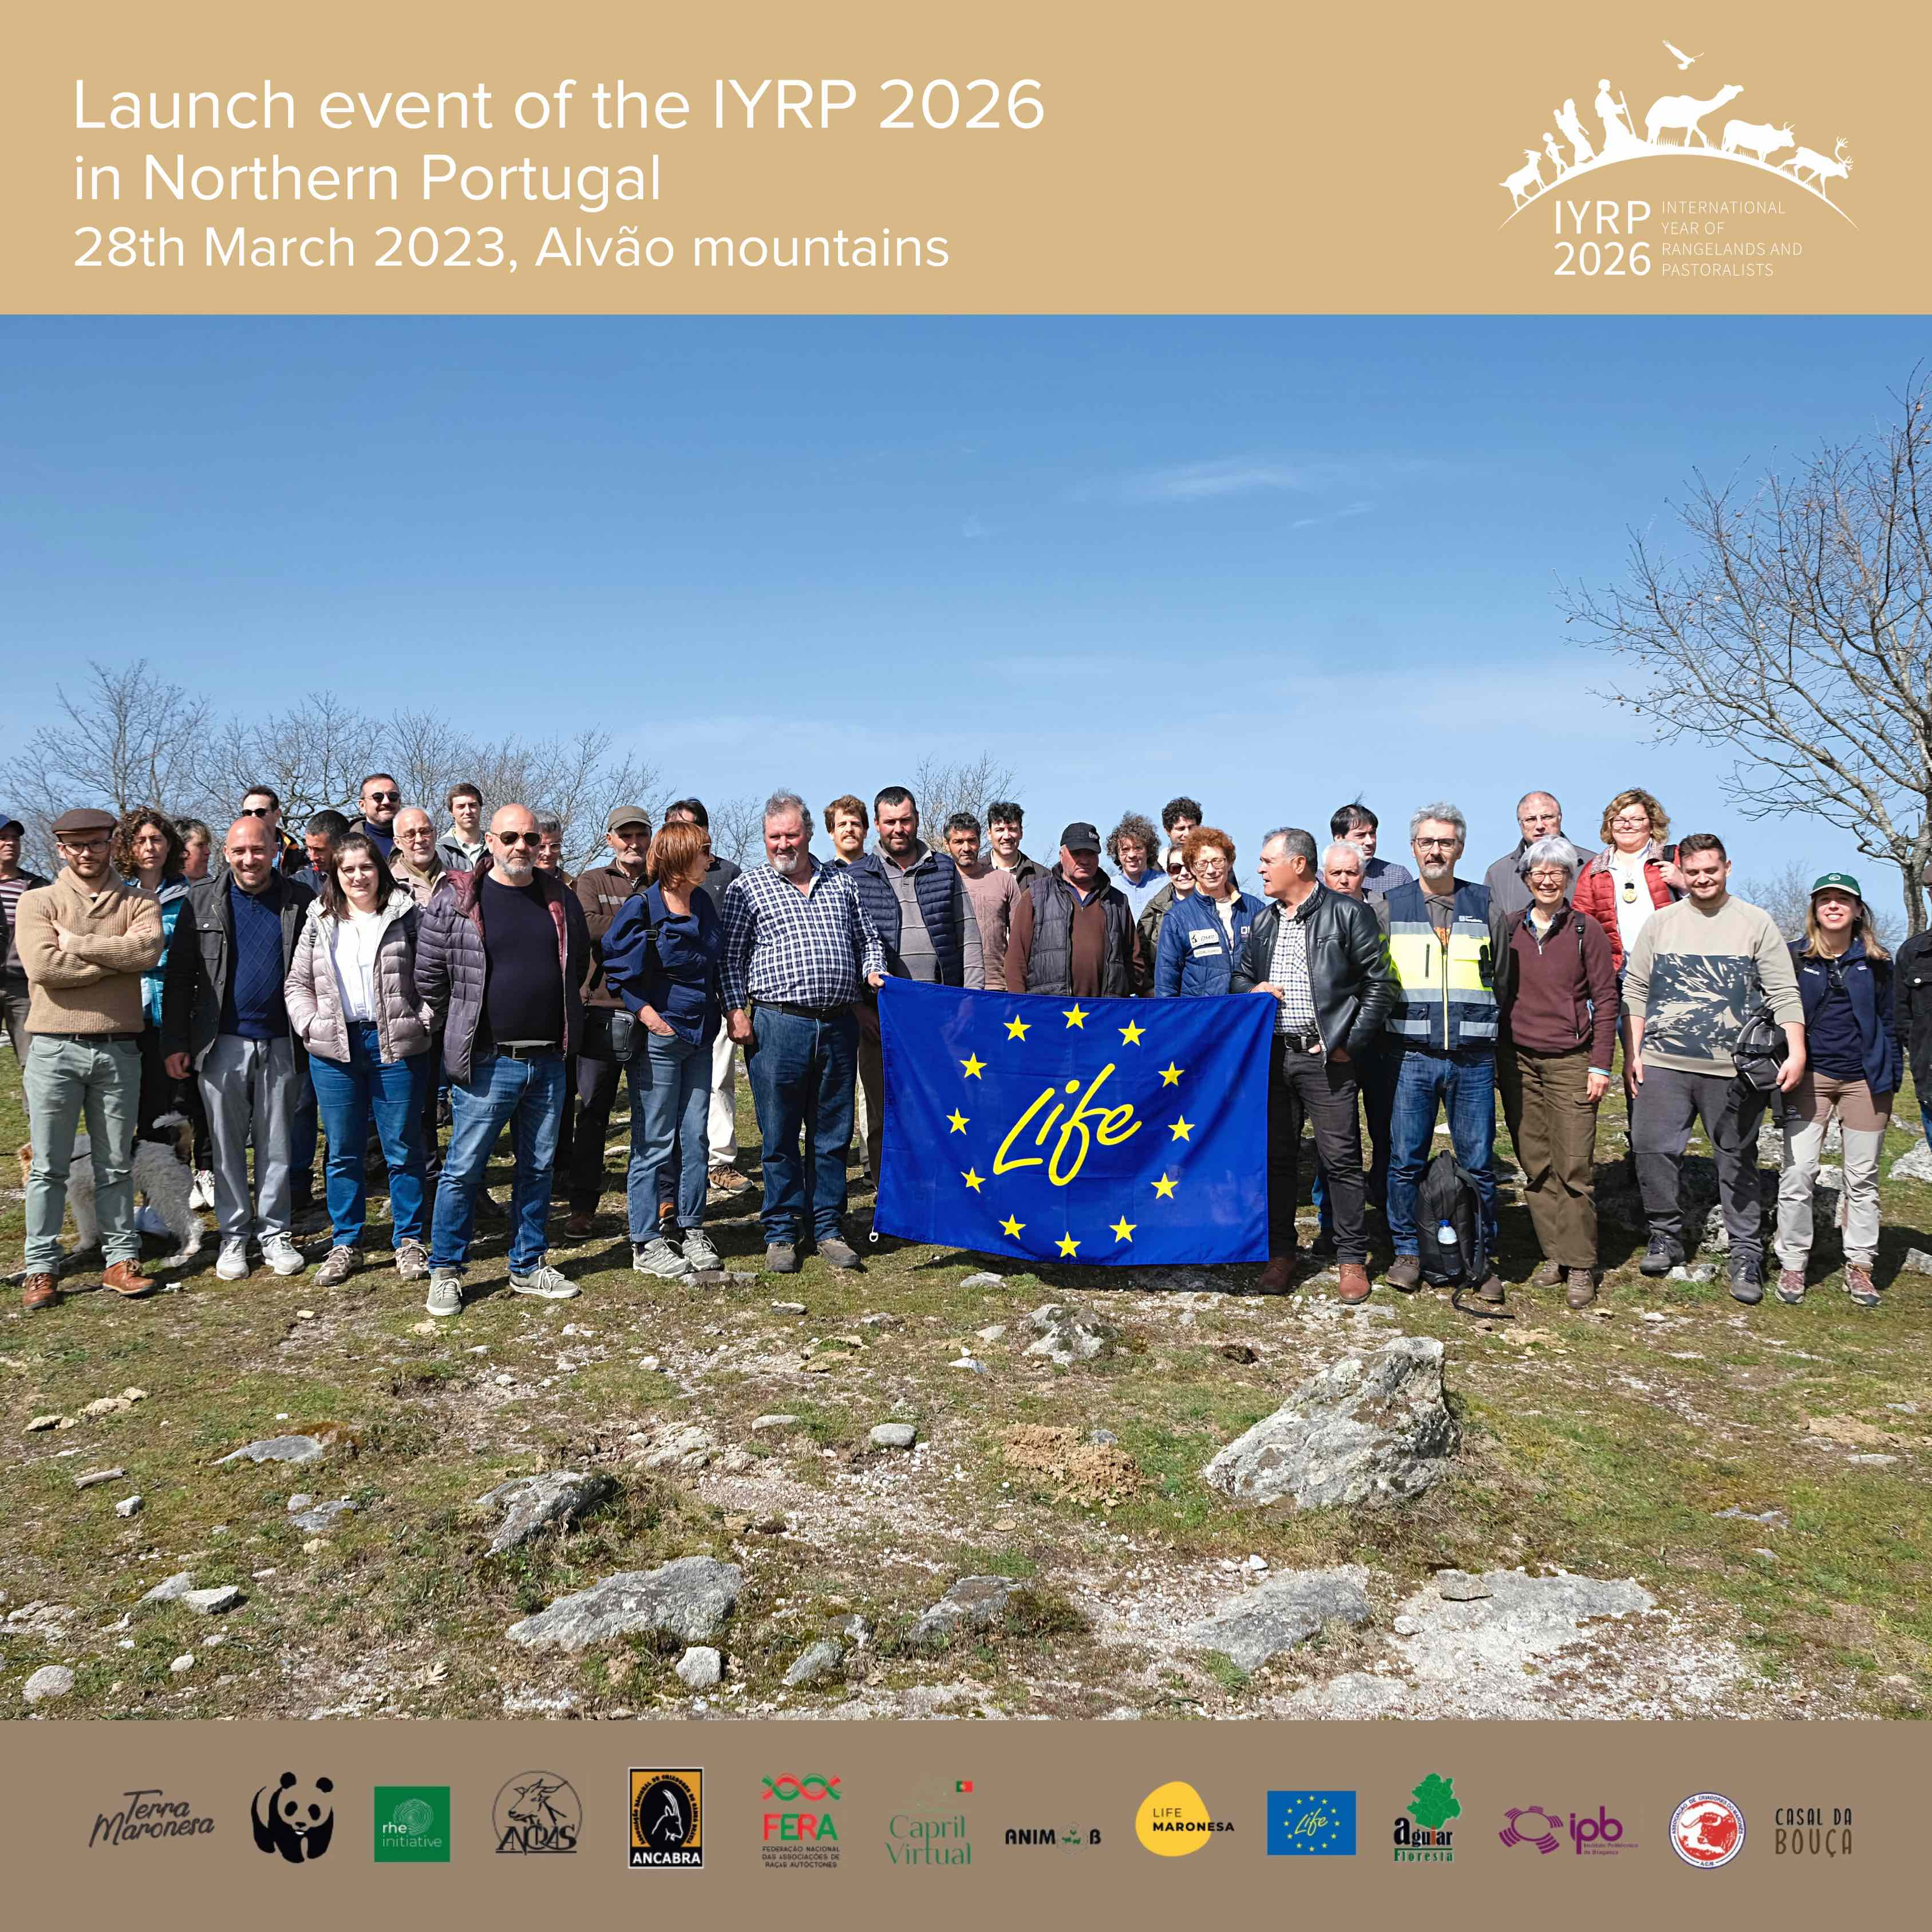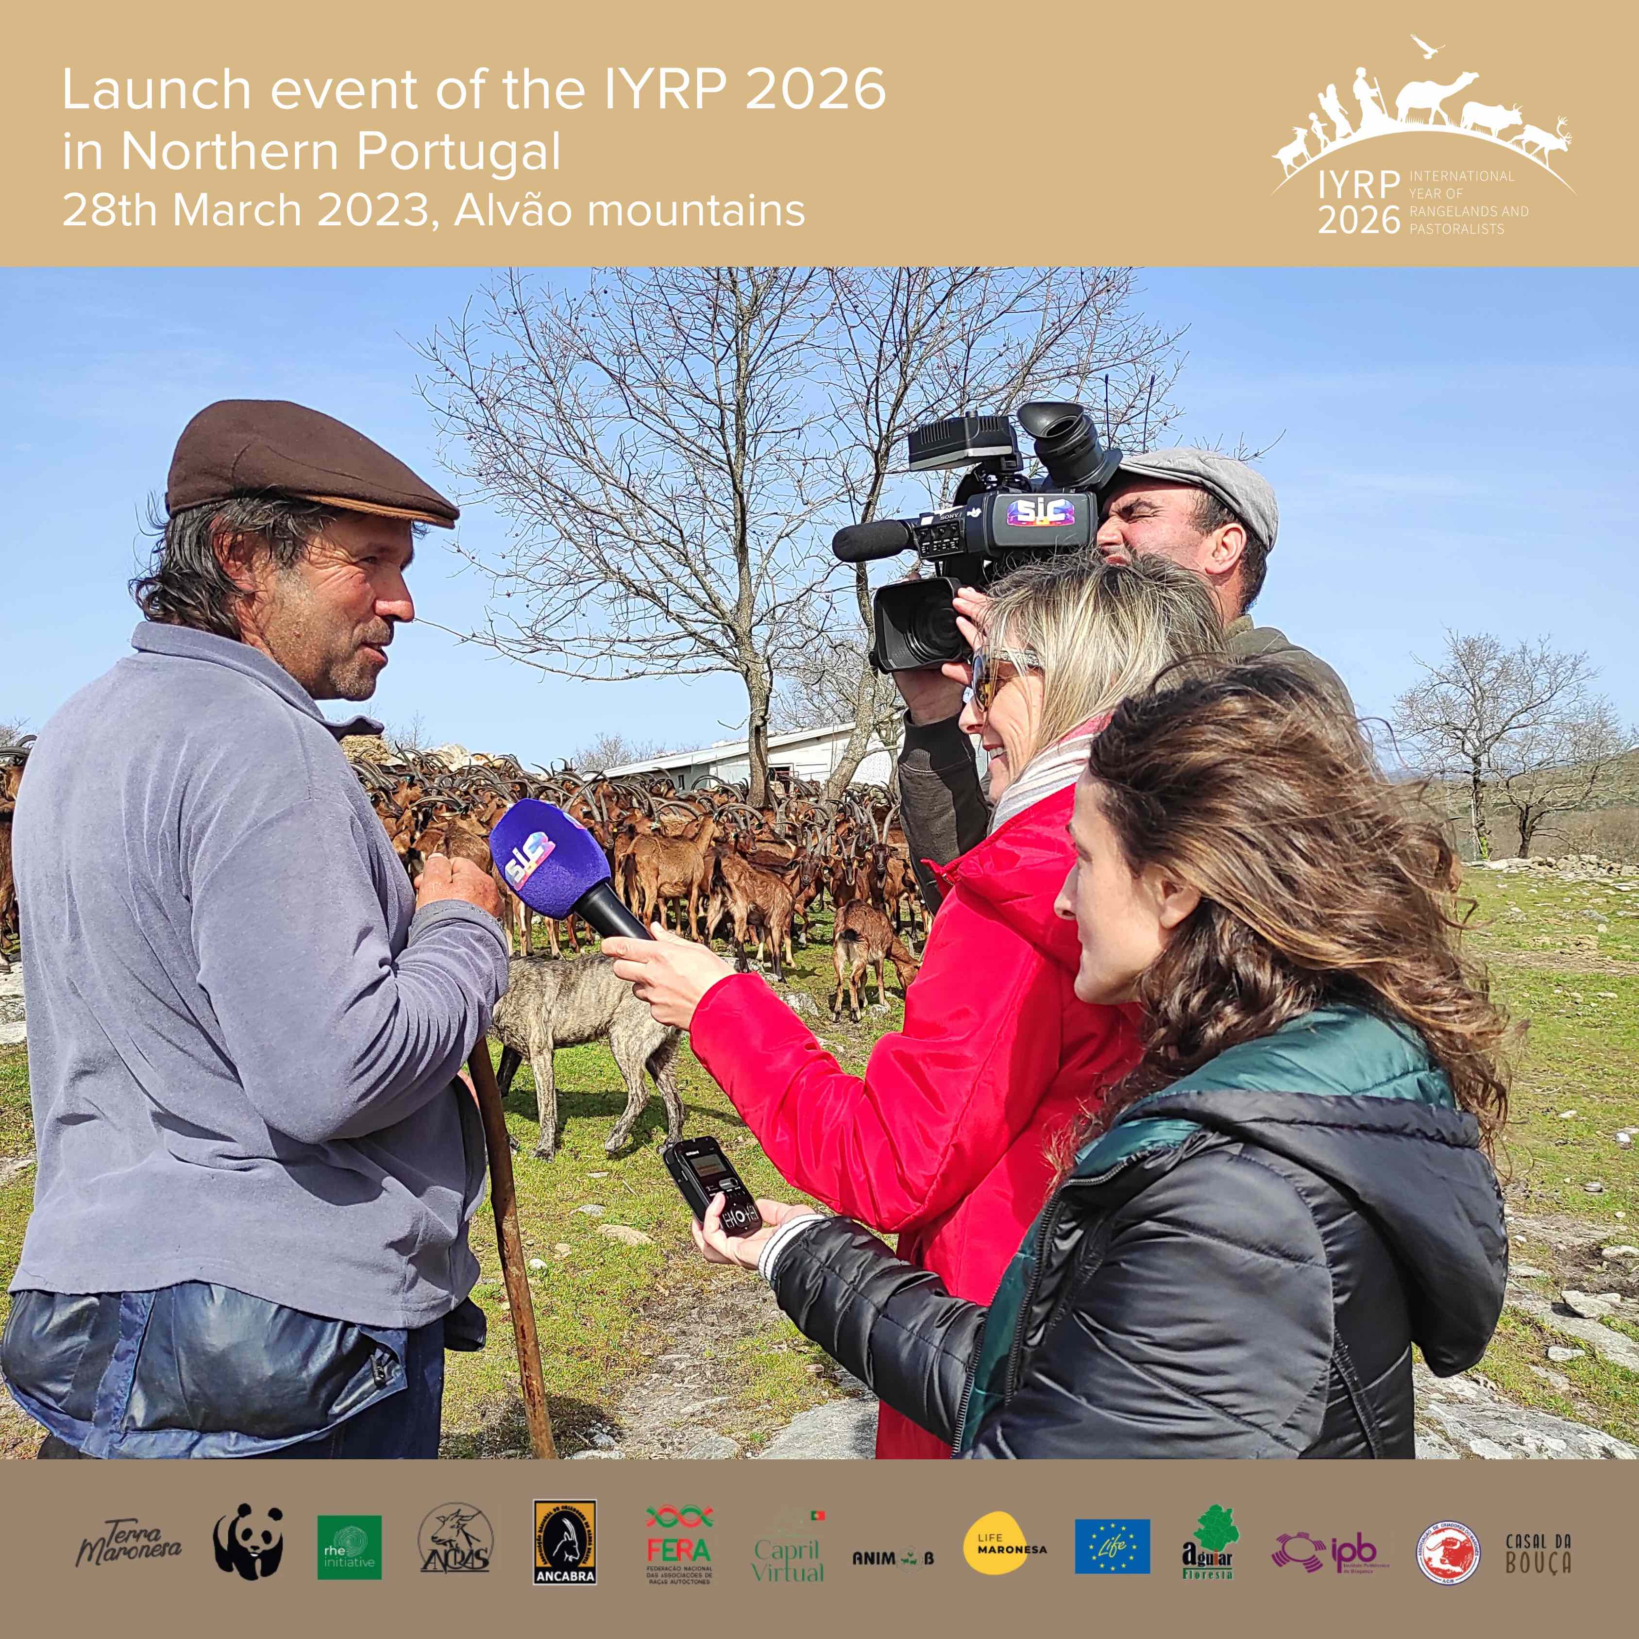
Photo: Daniela Parente Photo: Julio Sa Rego

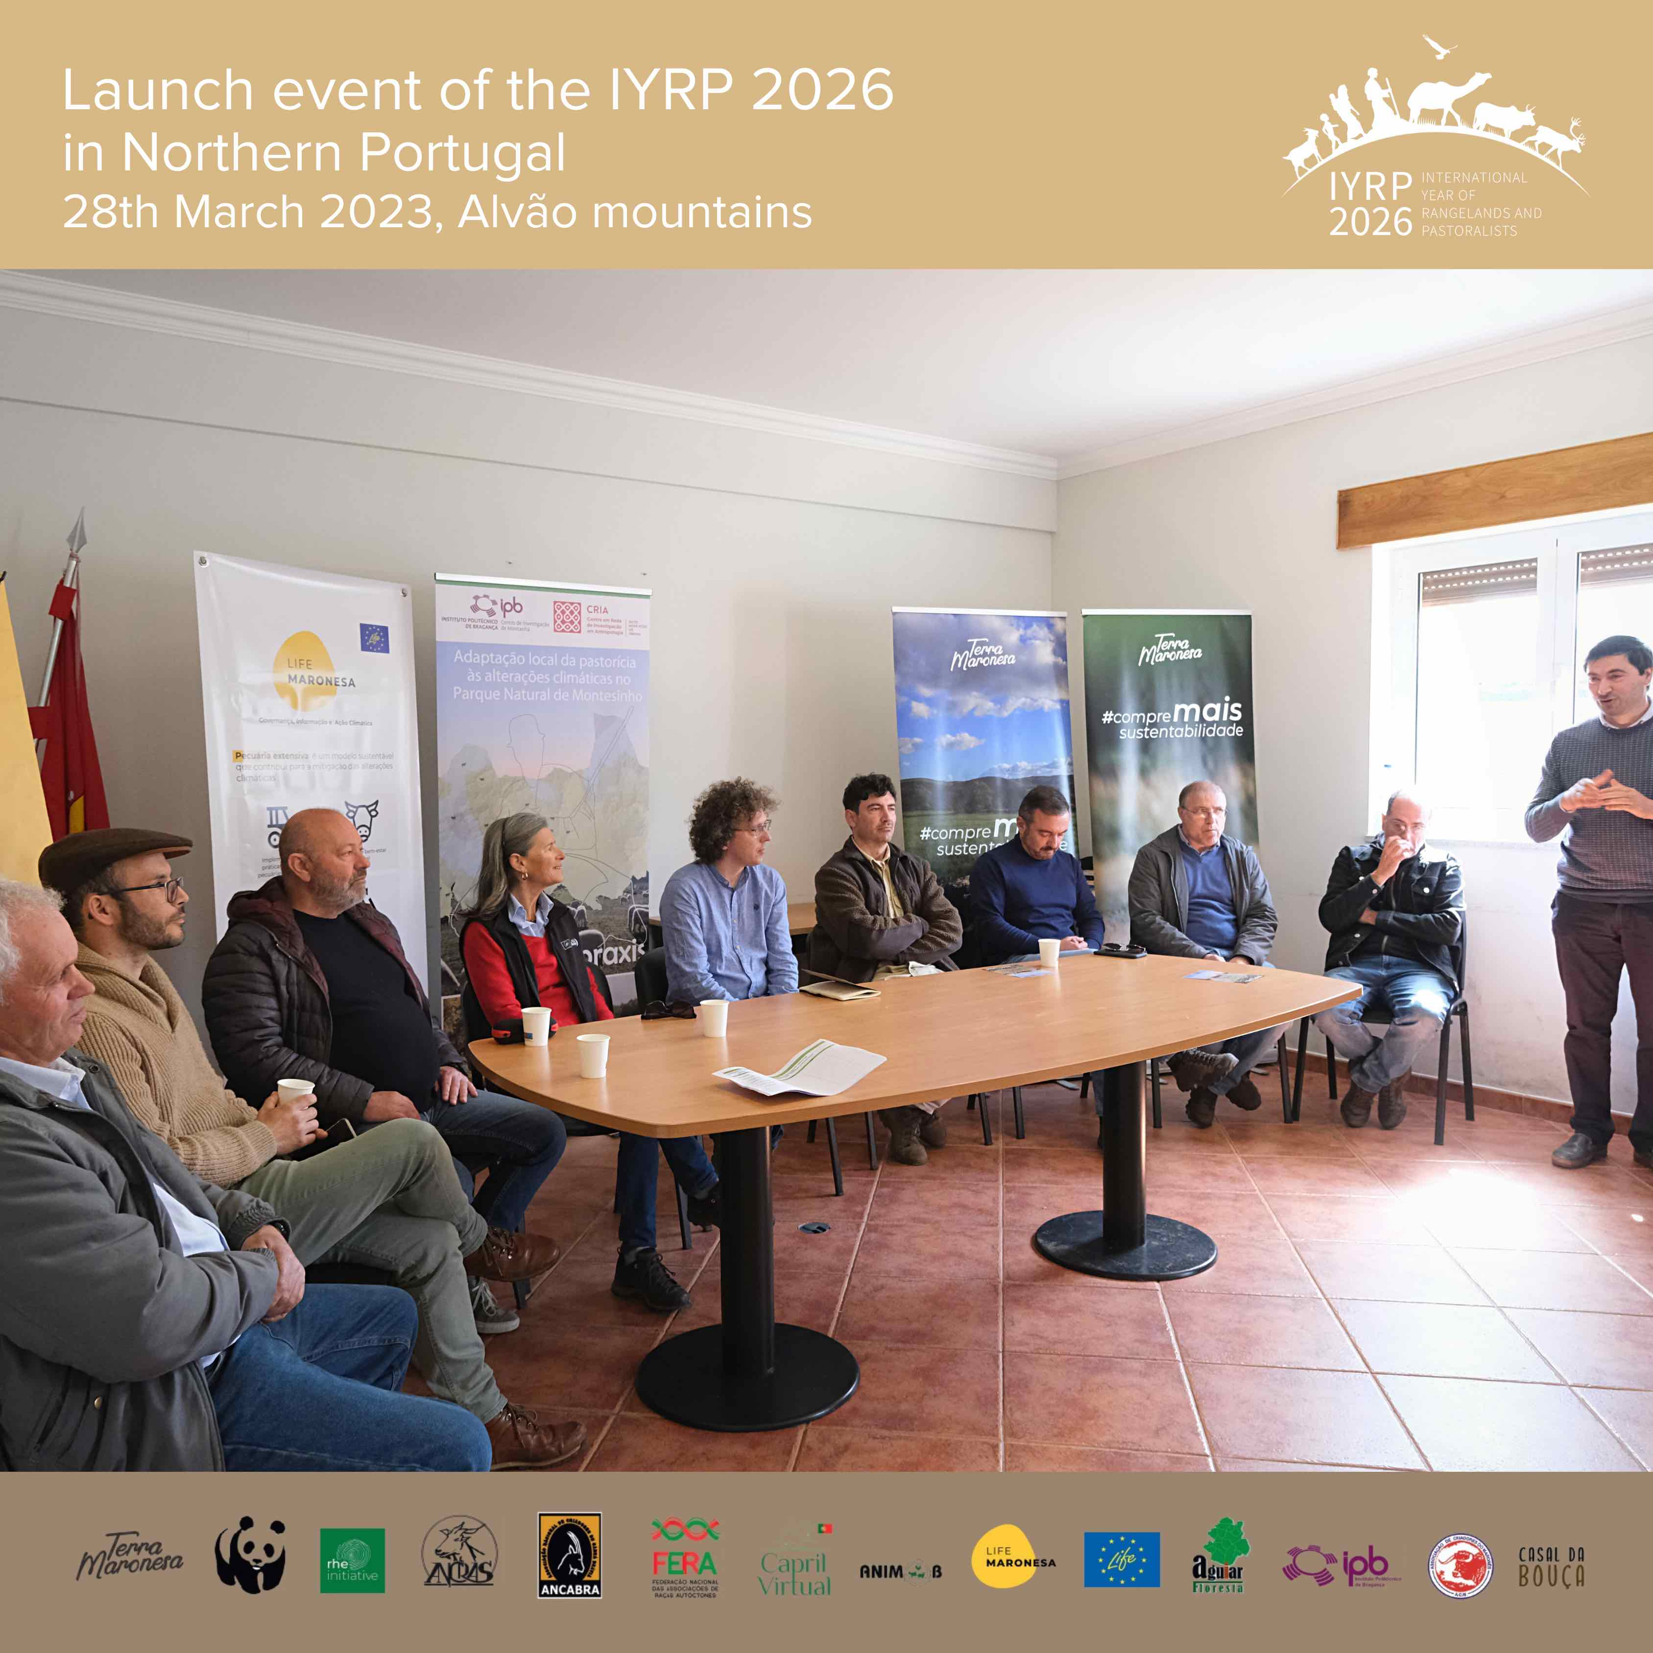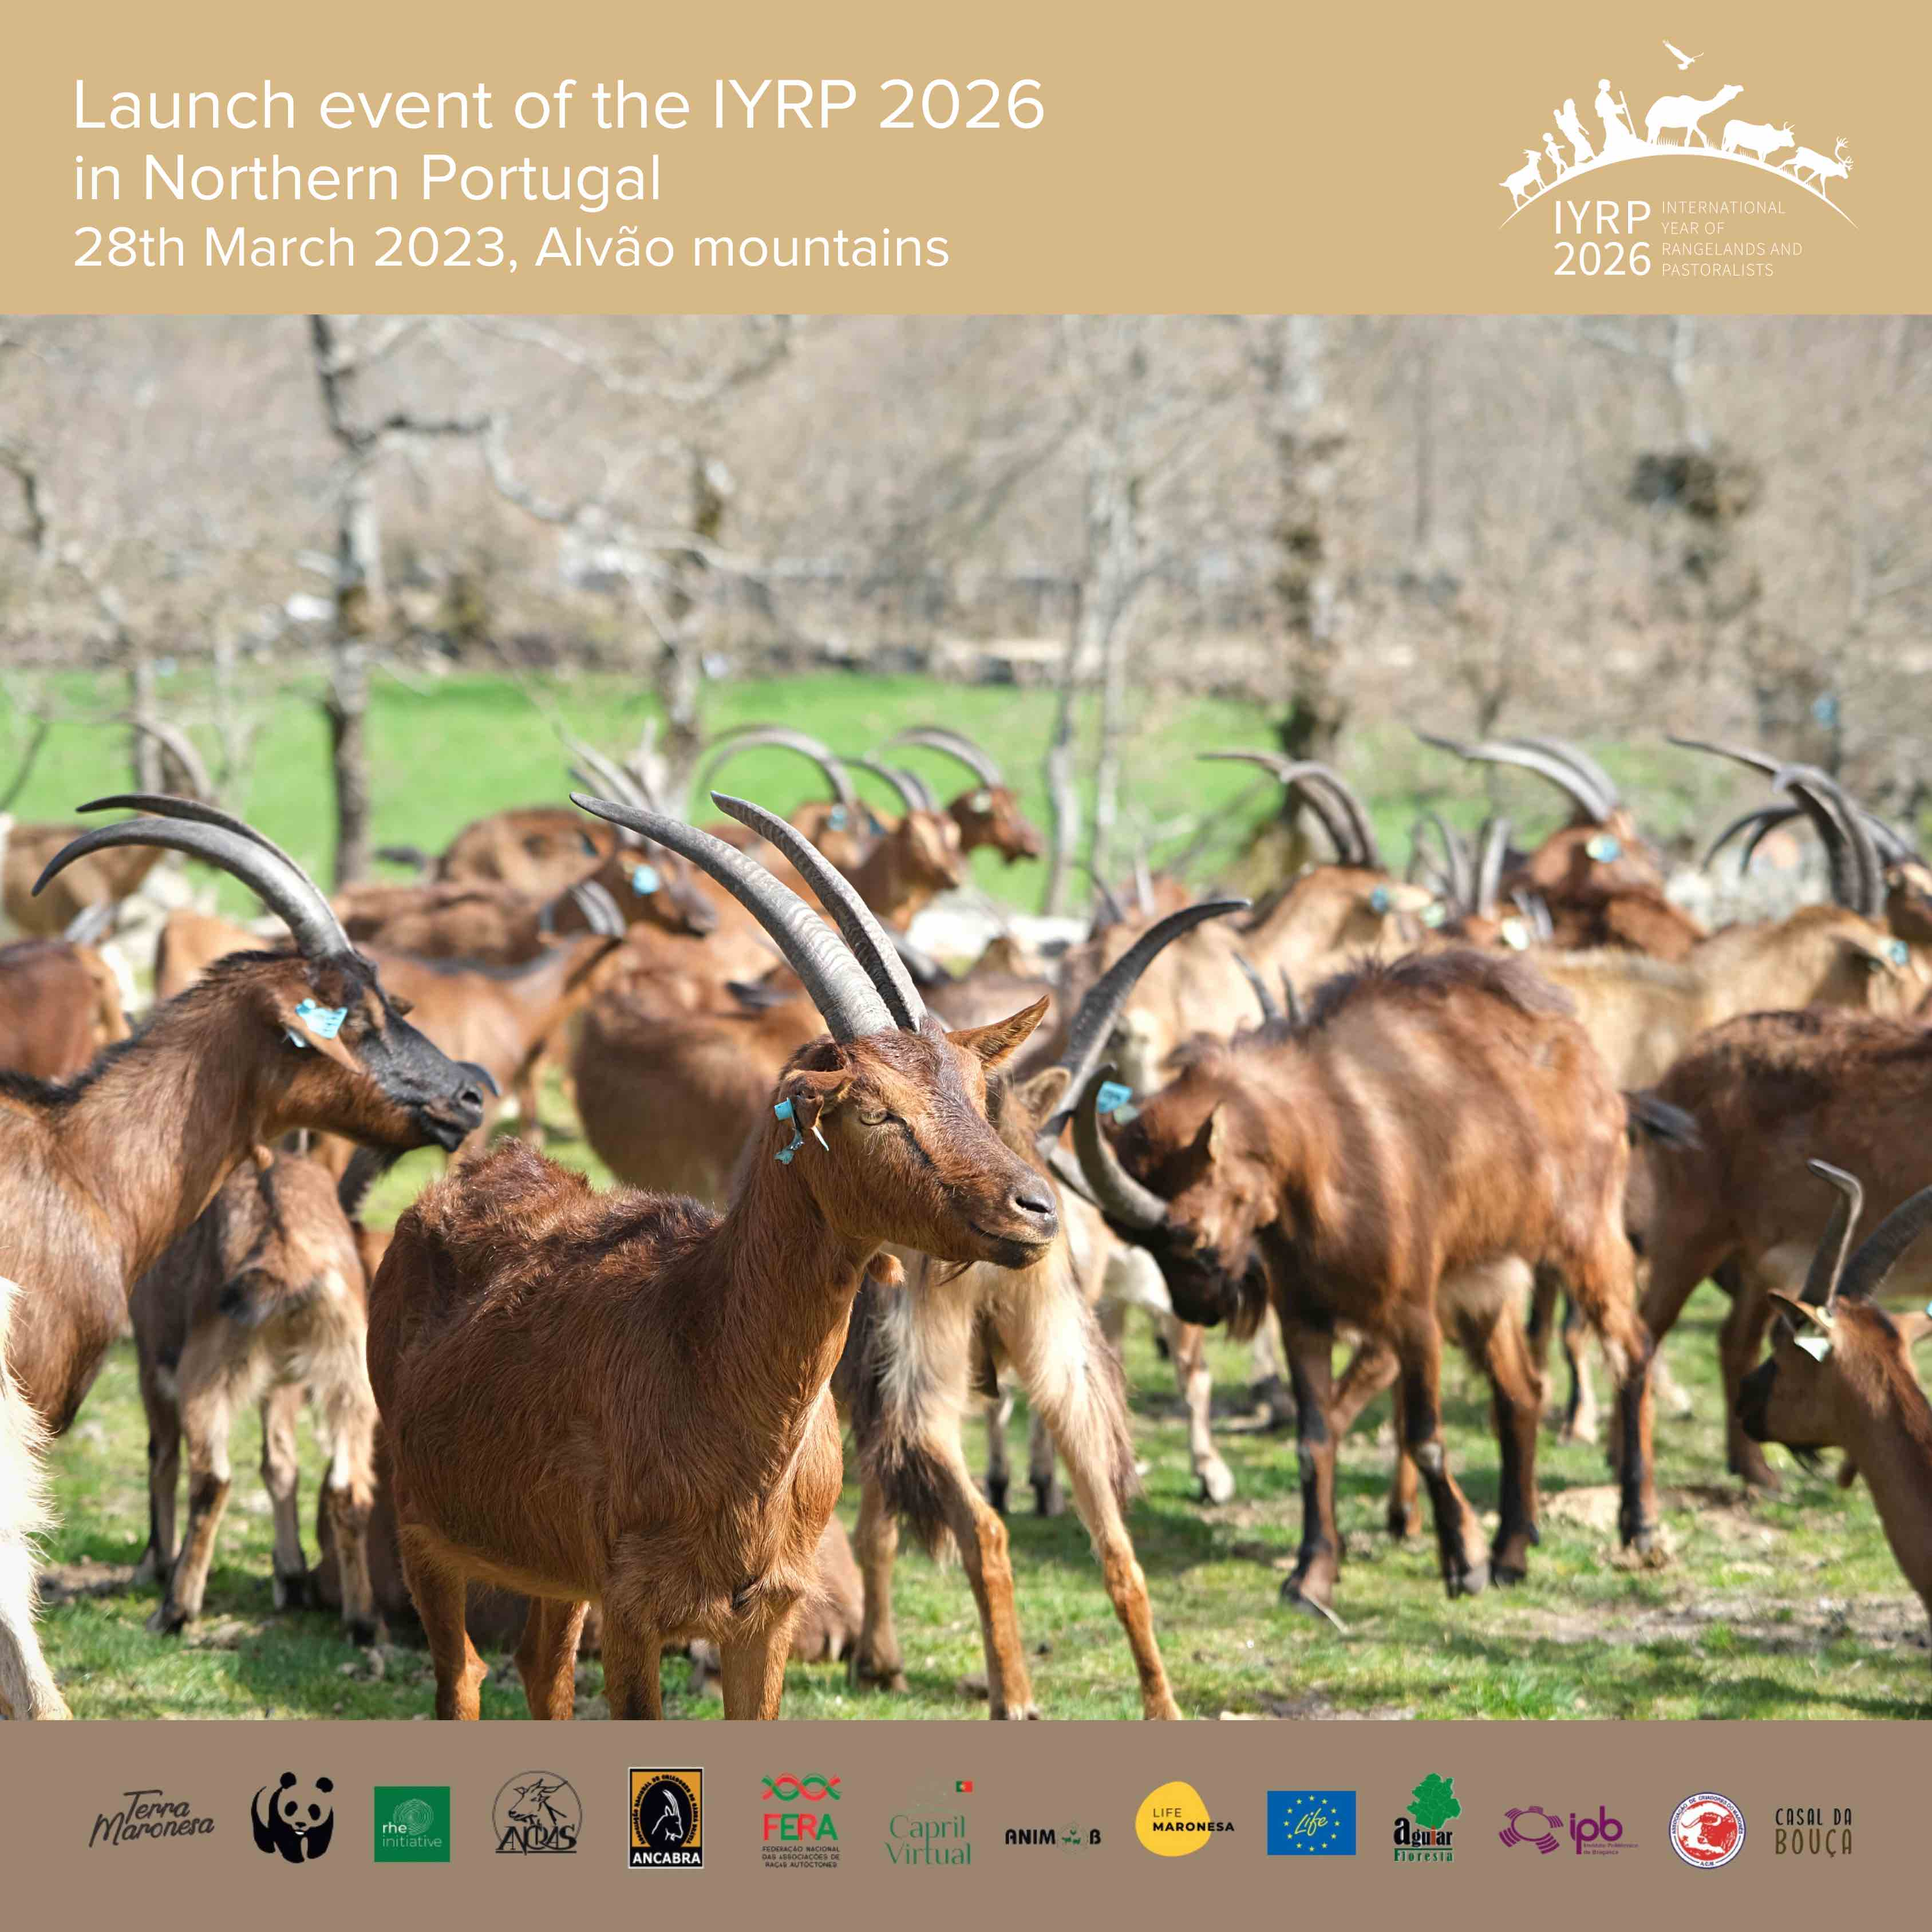
Photo: Daniela Parente Photo: Daniela Parente
Design: Yolda Initiative

Video clip of the event: https://www.facebook.com/terramaronesa/videos/6684329921581590
Facebook: https://www.facebook.com/IYRP2026/posts/pfbid032ftUctb1GZRnSwKLRcPgy3CTfgSz83dFLNYNhxE1sSD6Twcnc8KU2cJiSzp9zfrWl
Instagram: https://www.instagram.com/p/CquzQqXozJN/?igshid=YmMyMTA2M2Y=
Twitter: https://twitter.com/IYRP2026/status/1644324942006169607

